RYA Yachtmaster™ Theory Course
Next RYA Yachtmaster Theory course: 30 March to 30 April 2026
Course length: 5 weeks
Price: $1,590
Timing: Monday, Tuesday, Wednesday, Thursday, evenings after work 5:00pm to 7:00pm
OR
Timing: Tuesday, Wednesday, Thursday and Friday mornings before work 05:00 to 07:00am
- Your RYA Yachtmaster™ Certificate is often the ultimate aim of aspiring skippers.
- It is a world recognised, highly respected qualification, proving your experience and competence as a skipper of a yacht or even a commercial vessel.
- It is endorsed by both AMSA (in Australia) and the MCA (in the United Kingdom) for commercial use up to 200 tonnes and less than 24metres. One can either apply for Yachtmaster™ Sail or Yachtmaster™ Power certificates, once you have completed the respective practical examination.
- Should a candidate wish to use her or his RYA Yachtmaster™ qualification as a commercial ticket, this qualification is only possible after “face-to-face” tuition, with invigilated in person exams
- You must have at least 40 hours face to face tuition, if you are seeking RYA Yachtmaster™ Offshore certification with endorsement for commercial qualifications (This is done either with AMSA or MCA with a simple email application).
- Your theory course equips you to navigate safely on coastal and offshore passages of almost any length.
- This course will take your theory knowledge to the highest world standard required for the Yachtmaster_{TM} Coastal and Yachtmaster_{TM} Offshore practical exams, concentrating on advanced navigation and meteorology skills, and a detailed understanding of the IRPCS. Your classes give you detailed focus on electronic aids to navigation under the latest RYA program named “digital first”.
- Students in the southern hemisphere have a southern hemisphere version of our training materials, ensuring that your theory course is relevant to you. You will also receive the Northern Hemisphere training publications to practice in both locations. Yachting Directions is the only RYA Training Centre to include this in the course structure and price, and to include in your course fee, all your publications to facilitate your learning.
- Yachting Directions RYA Yachtmaster_{TM} Theory online course is 40 hrs minimum of face to face tuition, taught as 2.0 hrs per day from Monday to Thursday, inclusive, each week x 5 weeks. These classes are conducted from 5.00am until 7.00 am, or from 5.00pm to 7.00pm. A recording is made available later that day if you miss the live class. The recordings also facilitate homework and easy revision before your assessment.
- The Theory Course size is a maximum of 12. The preferred course size is 4 to 6 students.
- Pre-requisites: RYA Day Skipper or similar.
- This theory course is a pre-requisite for your RYA Yachtmaster Offshore exam. Should you elect to undertake the RYA Offshore Yachtmaster certificate, you would then just do the bespoke RYA Yachtmaster Offshore exam preparation course. This can be conducted on a catamaran or a monohull.
- The Syllabus:
  - Chartwork: Chart information and symbols, position fixing, course shaping and plotting, Zones of Confidence, use of traditional instruments, Rising and Dipping Distances,
  - Pilotage, use of soundings, lights and nav aids as “signposts”
  - Passage Planning and preparation,
  - Use of almanacs and admiralty publications,
  - Electronic aids to navigation, including Radar, AIS, GPS, apps, and a range of software programs.
  - Tides & anomalies, Streams & Currents, Tidal Curves, Secondary Port Calcs, Computation of Rates,
  - Meteorology, taking and interpreting forecasts, plotting weather systems,
  - IRPCS, (Known as The International Regulations for the Prevention of Collisions at Sea),
  - Navigation in Restricted Visibility,
  - Customs Regulations, Flag etiquette,
  - Magnetic Compass and Gyro Compass,
  - Weather predictions using a barometer and by observations
  - Customs and excise regulations for cruising abroad
  - Diesel engine and Electric Propulsion/Advanced Battery Systems,
  - Safety at Sea, Maintenance, Stability, Radar,

Advantages of obtaining your RYA Certificate through Yachting Directions
- My commitment to bringing you through the learning process to not just make a Commercially certified Yachtmaster, but to make a great Commercially certified RYA Yachtmaster.
- Learning is spread out over 5 weeks to facilitate deep absorption of the course content, not a 5-day cram session.
- When you are looking to accumulate Miles to gain experience, I put you on vessels belonging to past students who are adventuring to far flung exotic locations or cruising the East coast of Australia. There is no financial involvement from me.
- Our RYA Yachtmaster courses are conducted in blocks of 4 days per week over 5 weeks, with a final weekend to cap off your learning and to sit the exams.
- We believe it is extremely difficult to absorb all the information needed to pass your RYA Yachtmaster theory exam, if you try to do a 5 day course.
- We facilitate you building your Miles and although we don’t do this with financial involvement, I still keep in touch to maximise your learning opportunities, mitigate your risk and maximise your safety.

What is included? -The Yachting Directions Coastal & Offshore Yachtmaster shore-based course kit. It contains your Yachtmaster Shore-based Notes, RYA practice charts, Course Exercises, RYA Navigation Exercises for Northern Hemisphere, a soft lead pencil and eraser. You also receive the RYA Navigation Handbook, Weather handbook, International Regulations for the Prevention of Collision at Sea, and Symbols and Abbreviations of Admiralty Charts and your course plotter (referred to as a Portland Plotter).

You can elect to receive these publications as e-books (recommended) or in hard-copy.

On successful completion of this course assessment you receive the RYA Yachtmaster / Coastal Skipper shore-based certificate.
TEXTS AND EQUIPMENT included with your RYA Yachtmaster theory course
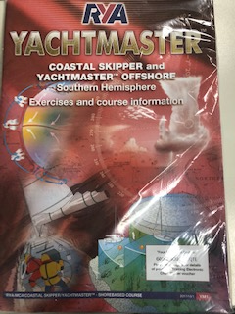  Course text  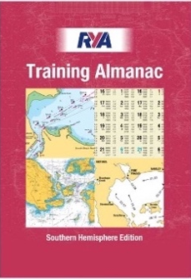  Included | 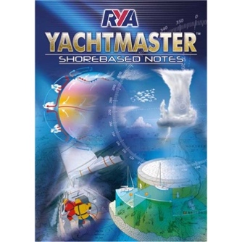Course text  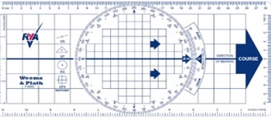  Included | 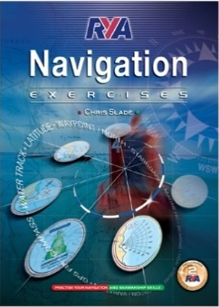  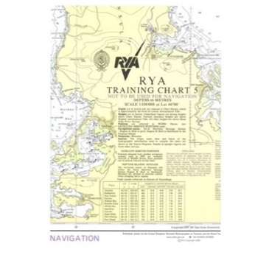 | 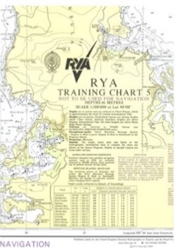  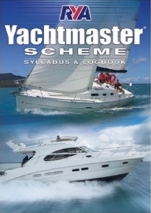
Included  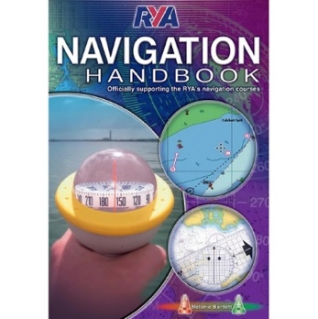  (rrp $25.00) | Included  (rrp $49.95) | Included Included  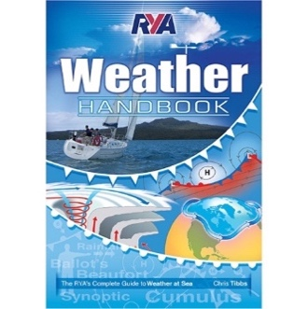  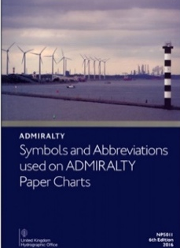  (rrp $65.00). (rrp $25.00)
(rrp $59.95) (rrp $85.00) (rrp 41.95)
Included Included Included

The RYA Yachtmaster™ Practical Course
Once you have completed your theory (shore-based) course, it’s time for your practical course.
Yachting Directions conducts its RYA Yachtmaster Sail practical courses through Atlas Sailing in Mosman Bay on the perfect training yacht, the Beneteau 40.7 named ‘Ticket of Leave’.

• Three types of RYA Yachtmaster exist. These are:
Coastal Yachtmaster, Offshore Yachtmaster, & Ocean Yachtmaster.

1. Coastal Yachtmaster/ Coastal Skipper certification involves a practical course (after your theory course).
2. The Offshore Yachtmaster certification doesn’t involve a separate practical course. However Yachting Directions conducts a bespoke exam preparation practical course known as RYA Yachtmaster Exam Prep.
3. The Ocean Yachtmaster requires an ocean passage using celestial navigation.

• The Coastal Yachtmaster courses teach skippering techniques for people with considerable knowledge of sailing
and navigation, wanting to undertake extended coastal passages by day and night.
• Like the Day Skipper course, this course consists of skippered passages in a variety of situations. Each trainee will skipper more challenging passages and learn more about passage planning, pilotage by day & night, boat handling, safety and emergency situations. It is a satisfying but intensive course.
• You are expected to complete the Coastal Skipper/YachtmasterTM theory or Offshore YachtmasterTM theory course before a attempting a practical course as there isn’t the time to teach you theory, onboard.
• Accredited RYA Coastal Skippers / RYA YachtmastersTM should be able to undertake more difficult passages by day or night and handle the yacht in more demanding conditions.
• Course content includes Passage planning, Preparation for sea, Pilotage, Passage making, Yacht handling under power, Yacht handling under sail, Adverse weather conditions, Emergency situations. By the end of the course, you should have the knowledge, if not the experience, to be a YachtmasterTM
• Unlike other courses in the RYA Cruising Scheme, there is no formal practical training to complete, in order to become a YachtmasterTM Offshore. Instead, provided that you have sufficient experience/sea- time, you can put yourself forward to test your skills / knowledge. However, we still recommend the “exam prep course”.
• Many YachtmasterTM Offshore candidates choose to book into an RYA training centre such as Yachting Directions, for some tailor-made tuition to prepare them for the exam, but this is not compulsory. We at Yachting Directions call this course Yachtmaster Exam Prep. It is generally a 4-day course, with most candidates taking 4 days. But remember, it is entirely dependent on your skill.
• RYA Yachtmaster Offshore practical exams or assessments cannot be conducted by the Training Centre you attended or by the instructor you used. You book your exam through your RYA recognised training centre. Please allow a minimum of 10 working days for an examiner to be allocated to you.
• RYA Yachtmaster Coastal Skipper practical course and exams are conducted by Yachting Directions, in conjunction with Atlas Sailing, operating out of Mosman Bay in Sydney.
• The RYA Yachtmaster Offshore and RYA Yachtmaster Coastal qualifications can be endorsed as commercial qualifications with worldwide application. This is a straightforward administrative process requiring a nominal fee and a medical assessment.
• https://www.rya.org.uk/courses-training/exams/Pages/book-your-exam.aspx

RYA Yachtmaster Coastal & Offshore Practical Exam Syllabus
1. International Regulations for the Prevention of Collisions at Sea
- General Rules (1-3)
- Steering and sailing rules (4-19)
- Lights and shapes (20-31)
- Sound and light signals (32-37)
- Signals for vessels fishing in close proximity
- Distress signals

      - 2 Safety. The safety briefing
      - Safety Harness
      - Life jackets
      - Distress signalling
      - Stability
      - Fire prevention and fighting
      - Life rafts
      - Knowledge of rescue procedures
      - Helicopter rescue
      - Emergency management – MOB, Fire, sinking
      - Man Overboard Exercises

RYA Yachtmaster Coastal & Offshore Practical Exam Syllabus (continued)
3 Boat Handling
- Coming to & weighing anchor under power & sail in various conditions of wind /tide.
- In all berthing and unberthing situations and in various conditions of wind and tide.
- In recovery of MOB and being able to describe the effects of cold-water shock and the aftercare requirements of a casualty who has been in the water.
- When towing under open sea conditions and in confined areas.
- Controlling your yacht in a confined spaced under power, or under sail.
- In boat handling in heavy weather.
- When using helmsmanship and sail trim to sail to best advantage.
- Using warps for securing in an alongside berth and for shifting berth or winding.

4 General seamanship
- Properties and uses of synthetic-fibre ropes
- Knots
- General deck work at sea and in harbour
- Engine operations, routine checks and troubleshooting
- Improvisation of jury rigs following gear failure

5 Responsibility of the skipper
- Can skipper a yacht and manage the crew, duties, responsibilities and welfare
- Delegation of responsibilities, navigation and watch-keeping
- Preparing the yacht for sea
- Preparing the yacht for adverse weather
- Upwind sailing in adverse weather. Downwind sailing in adverse weather
- Tactics for heavy weather and restricted visibility
- Emergency and distress situations eg sinking, abandoning ship, fire
- Victualling for a cruise and feeding at sea
- Customs procedures
- Standards of behaviour and courtesy
- Tidal height and stream calculations
- Buoyage and visual aids to navigation

6 Navigation
- Charts, navigational publications and sources of navigational information
- Chartwork, including position fixing and shaping course to allow for tidal stream and leeway
- Instruments including compasses, logs, echo sounders, radio navigation aids and chartwork instruments
- Passage planning and navigation tactics
- Pilotage techniques and preparing a plan, by both day, and night
- The use of soundings, transits, clearing bearings, bouyage, back, & forward bearings, port and harbour regulations, tidal considerations
- Navigational records
- The limits of navigational accuracy and margins of safety
- Lee shore dangers
- Use of electronic navigation aids for passage planning and navigation
- Use of waypoints and routing
- General understanding of radar
- General understanding of AIS
- Navigational techniques for reduced visibility

7 Meteorology
- Definition of terms
- Sources of weather forecasts
- Weather systems and local weather effects
- Interpretation of weather forecasts, barometric trends and visible phenomena
- Ability to make passage planning decisions based on forecast information

8 Stability

9 Radar
- Obtaining a position fix
- Determining risk of collision

